KS Initial Assessment/ Practice Tests Learner Guide

- Please visit: http://keyskills4u.excellencegateway.org.uk/tests/2007/CdDemo.html
- Launch ‘Choose a test then click on ‘start test’ to open it’’
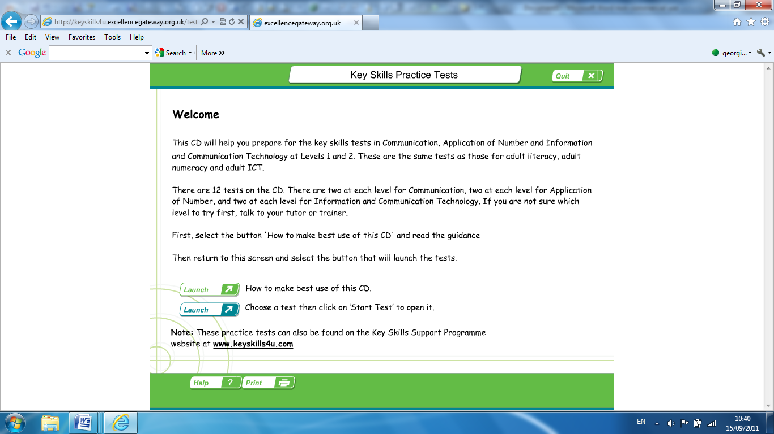
- Choose ‘Communication level 1, Start Test A’
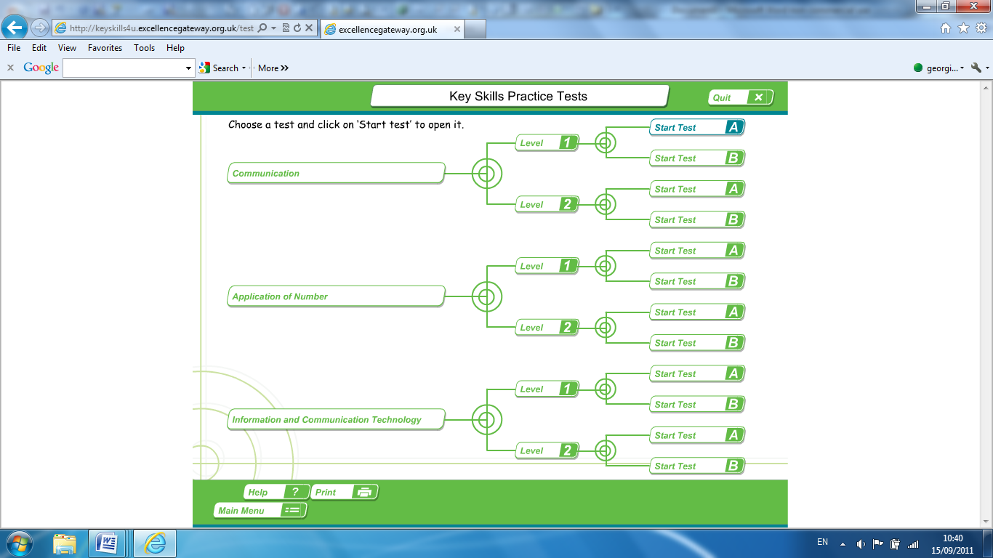
- Start your test. Read the paragraph/leaflet or other text. You will see a question to the right of the screen relating to the text you have just read. Select your answer from the multiple choices, by clicking your mouse on the box beside your chosen answer.
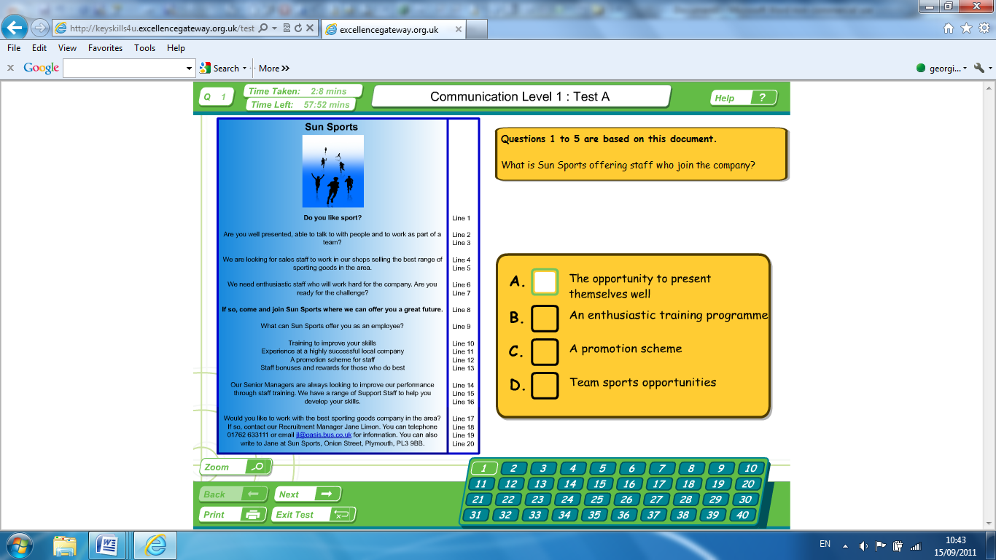

- Once you have answered the question, please click on ‘next’ to continue the test.
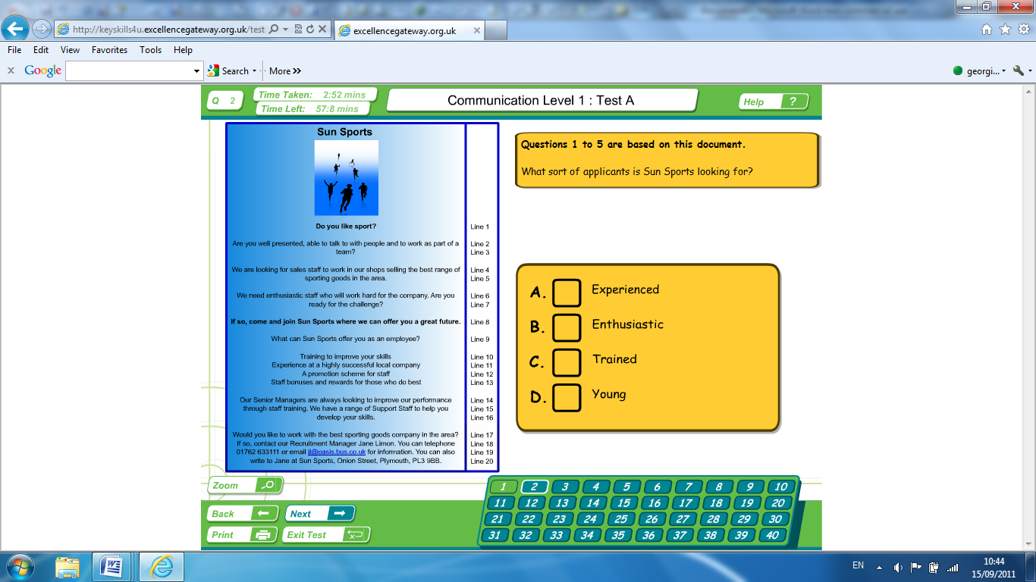
- Do this until you have completed the test.
- Once you have answered all 40 questions please click on ‘Exit test’
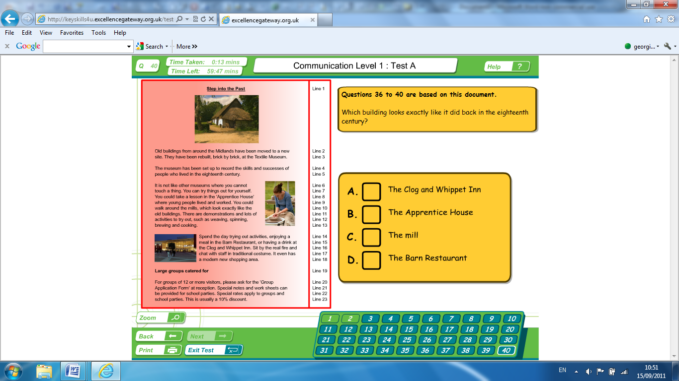

- You will then see an option box, click on ‘Yes’
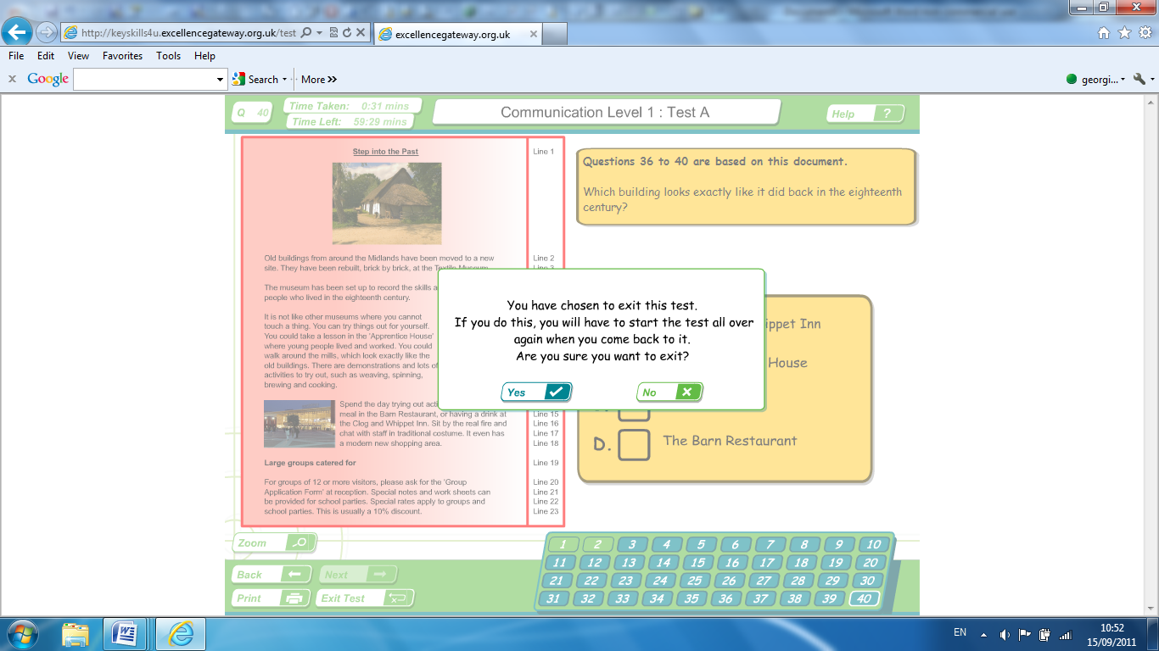

You will then be provided with a review of your test including your result.
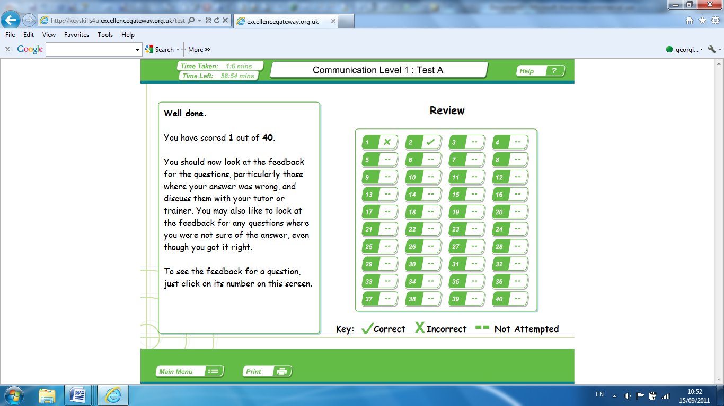

- You must now print a copy of your results. Failure to do so will mean that you must re-take the test.
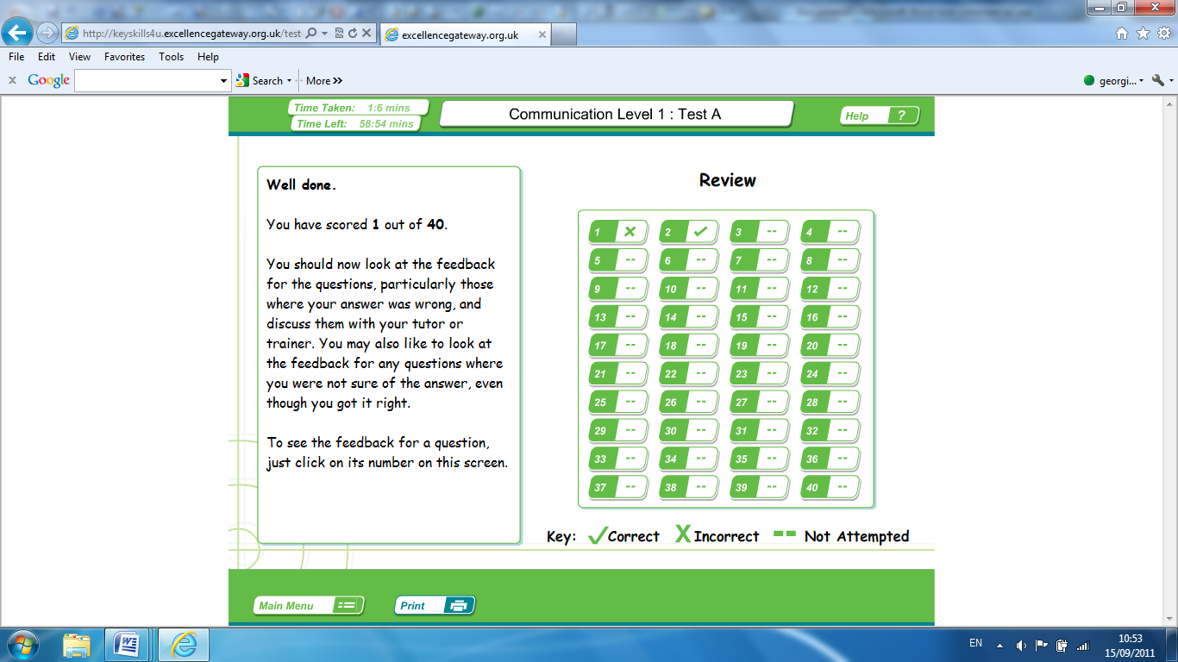
Congratulations, your Communication initail assessment or test is now complete.

- Please now choose ‘Main Menu’ to repeat the process for Application of number:

